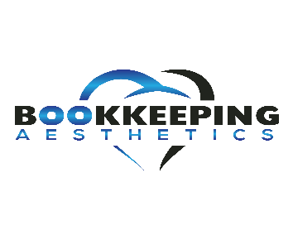

BookkeepingAesthetics.com Monthly Digest

Your Business Tax Return is Due!
The deadline for business taxes is fast approaching!
by Annette Woods on March 04
It’s that time again! I wanted to send you a friendly reminder to file your business taxes by March 15th! This applies to you if you have an S Corporation or Partnership on a calendar year for tax purposes.
If you’re not able to submit your business tax return on time - don’t worry - you can file for a 6-month extension to file to the IRS.
If you would like some help getting your books ready, feel free to schedule a free consultation below:

Schedule Your Free Consultation

THIS MONTH’S
TOP STORY

Common Business Tax Credits
by Annette Woods on March 04
Business tax credits are a great way to reduce your tax liability and something we focus on here at Bookkeeping Aesthetics. Here are some common tax credits you may qualify for:
- Small employer pension plan startup costs. Did you recently start (or have been thinking about starting) a retirement plan for your employees? Great! You may qualify for a tax credit.
- Work Opportunity tax credit. Did you recently hire a military veteran, person on food stamps, or ex-felon? Then you may qualify for this huge tax credit!
- Small employer health insurance. Did you recently start (or have been thinking about starting) a health insurance plan for your employees? Great! You may qualify for a tax credit.
- Employer credit for paid family and medical leave. Do you provide paid family and medical leave in your business? You may qualify for a tax credit
If you are interested in getting your books in order to find out if your business qualifies for the tax credits listed above (or any other tax credits). Schedule your free consultation below!

Schedule your free Consultation

Bookkeepingaesthetics.com

